DesignProcess-M365-SharePointOnline-Modern-Intranet

# Requirements / Business Case

1. **AS A**: Senior Executive/Board Group Communications Head – **I WANT**: To have my department manage a publishing focused intranet site– **SO THAT:** with the help from out-sourced/specialist digital-agency, drive key-categories of digital content & communications to reach across the organization level audiences.
2. **AS A**: [**Site Owner/Administrator**](https://www.linkedin.com/learning/configure-and-manage-sharepoint-online/sharepoint-online-administrators) – **I WANT**: A modern communications SharePoint online site – **SO THAT:** I can leverage modern web pages and webparts/apps, audience targeting and navigation and modern search of this intranet-site. I can grant/revoke/share access/permissions/site-groups-memberships and create/edit/delete lists/libraries/pages/apps to the SharePoint online intranet site.
3. **AS A**: Content-creator/Articles-author – **I WANT**: A modern page provisioned for my article, to be created also from blank/default or also, from custom page-templates – **SO THAT:** I can create/edit/update/change/delete page layout/sections, webparts and formatted content (text, images, videos, embedded apps etc.) and submit for approval the authored page and properties/settings/fields/metadata.

|  |  |  |  |  |
| --- | --- | --- | --- | --- |
| **AS A:** Digital agency manager **– I WANT:** milestones met with basic training and handover **– SO THAT:** Intranet is delivered within time & budget and estimates, with best standards and value to end-client. Notes to developer:  **•**I have attached designs for the 4 templates that are required**.** | | | | |
| •You will use out-of-the-box SharePoint components to implement these as closely as possible. | | | | |
| •You will work remotely as it’s the most efficient way to get things built quickly. | | | | |
| •You will create the Sharepoint mock-up site on your own server and email us through logins so that we can access and view progress. | | | | |
| •I will supply all graphics etc that you need, so email me your requirements | | | | |
| •The deadline for creation of the 4 templates with placeholder content has been agreed as Friday the 28th February. | | | | |
| •The migration to the client’s Sharepoint will be quick and easy once the staging version is approved. | | | | |
| **Tasks / Outcomes** | **Most Likely (Hrs)** | **Worst Case (Hrs)** |
|  |  |  |
| Theme - OOB and Adding Header Logo & Carousel etc | 1 | 1 |
|  |  |  |
| Theme/Page Settings - Custom script deployment | 4 | 5 |
|  |  |  |
| Menus - Static Megamenu with content-add; Footer menu | 2 | 2.5 |
|  |  |  |
| Blogs - Page/Template Content as Author (4 pages/templates) | 5 | 6 |
| **Blogs - Listing page - simple filtered OOB List View** | ***3*** | ***4*** |
| **Blogs - Listing page - List View formatter - Card View** | ***5*** | ***6*** |
|  |  |  |
| Quick links section - Buttons (8 no’s with images) | 1 | 1.5 |
|  |  |  |
| Links - Static Text webpart etc. | 2 | 2.5 |
| Links - SP-List (View formatter & Filtered Views) | 4 | 5 |
|  |  |  |
| Live-Portal build/deploy/config/usage - Documentation | 1 | 2 |
|  |  |  |
| **Total** (*Time excludes communications & developer-waiting…) | **28** | **35.5** |

# “SharePoint” – Motivation, Initiation & Action

SharePoint is the web-frontend portal/website product/solution within the broader Office/Microsoft 365 solutions offering. It has been around since more than a decade with traditional SharePoint & integrated services, only available for Windows Server OS now called On-Premises “SharePoint Server” versions (2007-2010-2013-2016-2019*).

SharePoint integration of other services like, Exchange/Active-Directory/MS-Graph, Content versioning/configuration-management, moderation/approvals, permissions & access-controls with Active-Directory users/groups or SharePoint groups, Search query and results fulfilment, Power platform (Automate/Workflows, App-builder, BI-Dashboards etc.), MS-Forms & Office and other third-party product integrations via Connectors, and Microsoft products like Dynamics and MS-Teams etc. – all the while lending its own unique features of managing of Libraries and Lists with default & custom columns. Some predefined document libraries with some special programmed features are part of site-templates when provisioned – like file-libraries such as Documents, Site Pages etc.

[**https://support.office.com/en-gb/sharepoint**](https://support.office.com/en-gb/sharepoint)

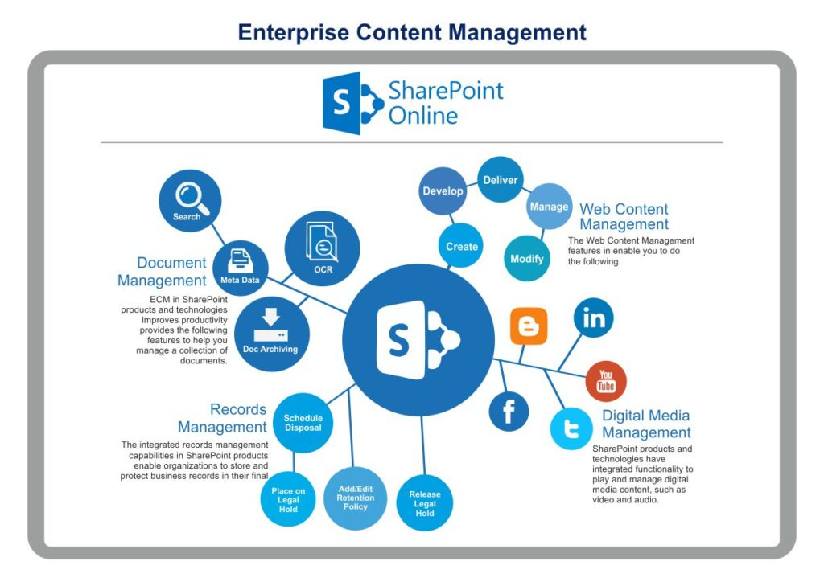[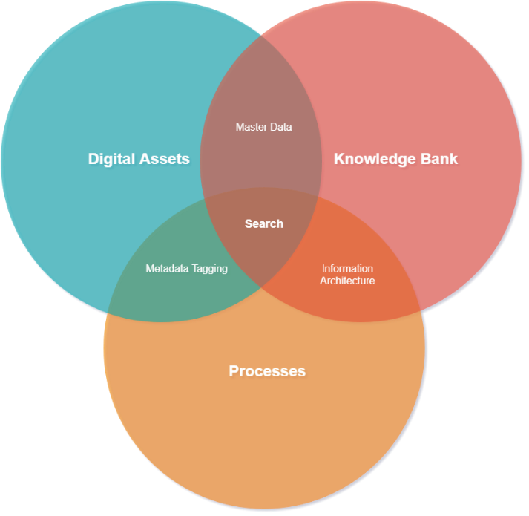](https://github.com/appflowitdeveloper/O365Azure)

[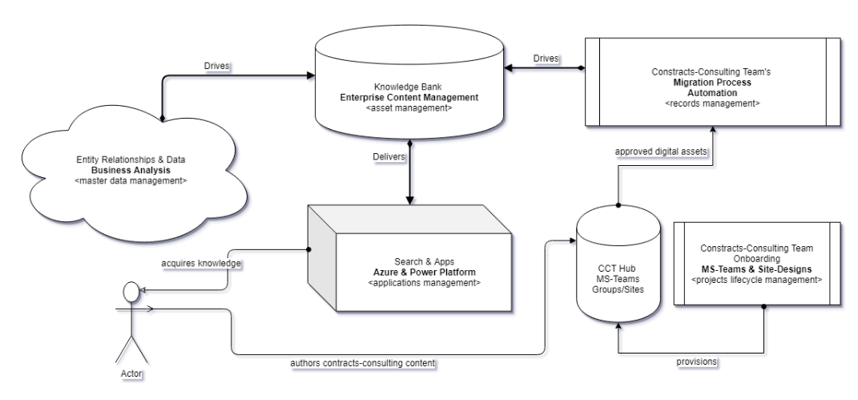](https://github.com/appflowitdeveloper/O365Azure/raw/master/SharePoint-Presales-Slides.pdf)

[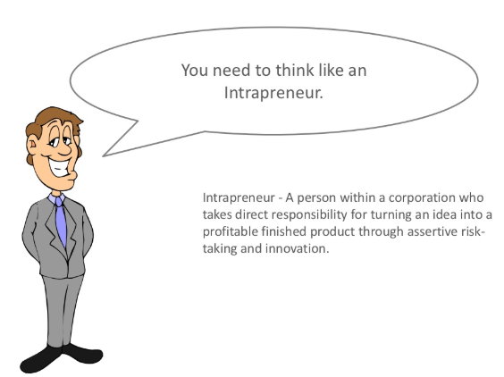](https://www.slideshare.net/benmcmann1/share-point-businessmodel)

**Suggested Intranet-Design Product for getting more out of your intranet! Empowering more of your Organization!**

<https://demos.shortpoint.com/>

[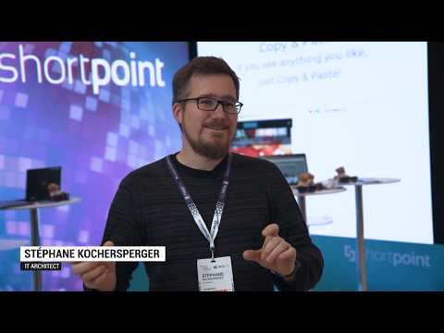](https://www.youtube.com/watch?v=EMMujHzOleo) [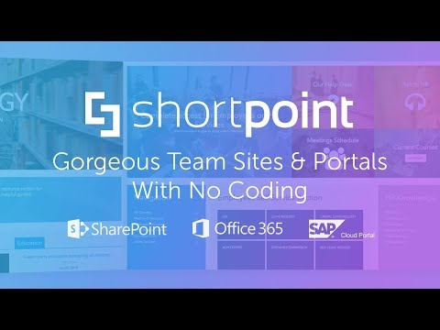](https://www.youtube.com/watch?v=F4eViASa6eM)

# Power Platform & Integration Connectors

[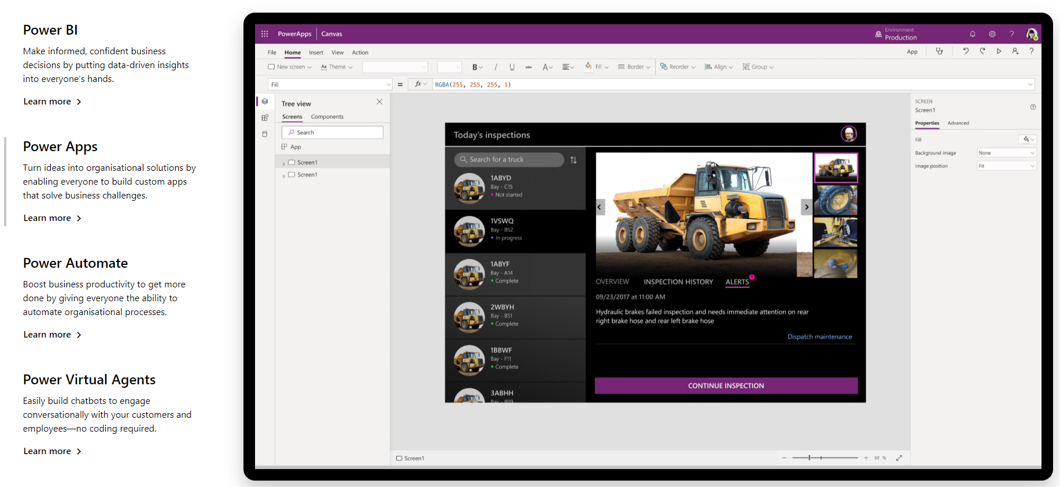](https://powerplatform.microsoft.com/en-gb/)

[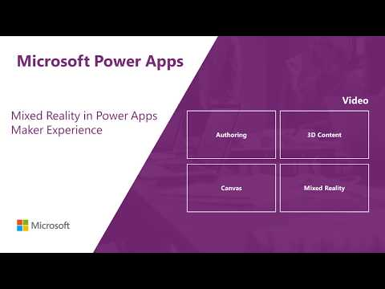](https://www.youtube.com/watch?v=39GWzYMp7JM)  [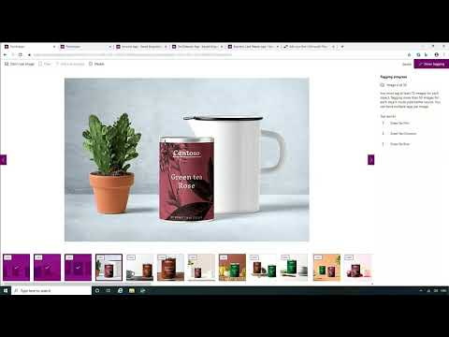](https://www.youtube.com/watch?v=MGtomFKVDys)

[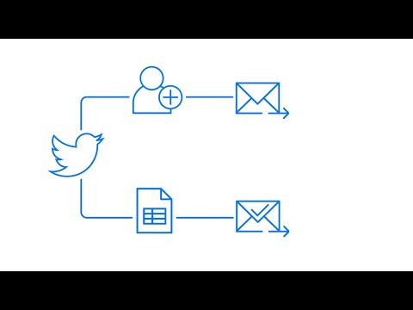](https://www.youtube.com/watch?v=hCuxuUaGC6Y) [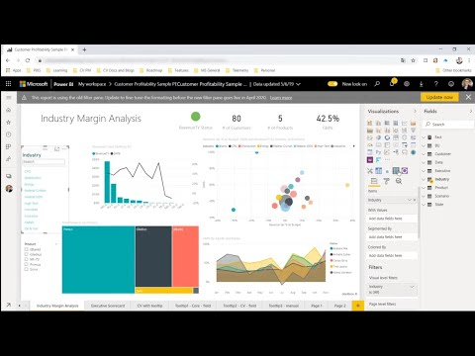](https://www.youtube.com/watch?v=W2CEUaZHOqE)

[**Power Apps Portals**](https://powerapps.microsoft.com/en-us/portals/)

[**https://www.youtube.com/watch?v=9ukaFsK_Njw**](https://www.youtube.com/watch?v=9ukaFsK_Njw)

# OneVision – Modern Publishing Intranet

This section and sub sections explore the “**OneVision”** intranet and how it has been presently setup/built and, potential improvements that can be considered for managing future capacities and processes.

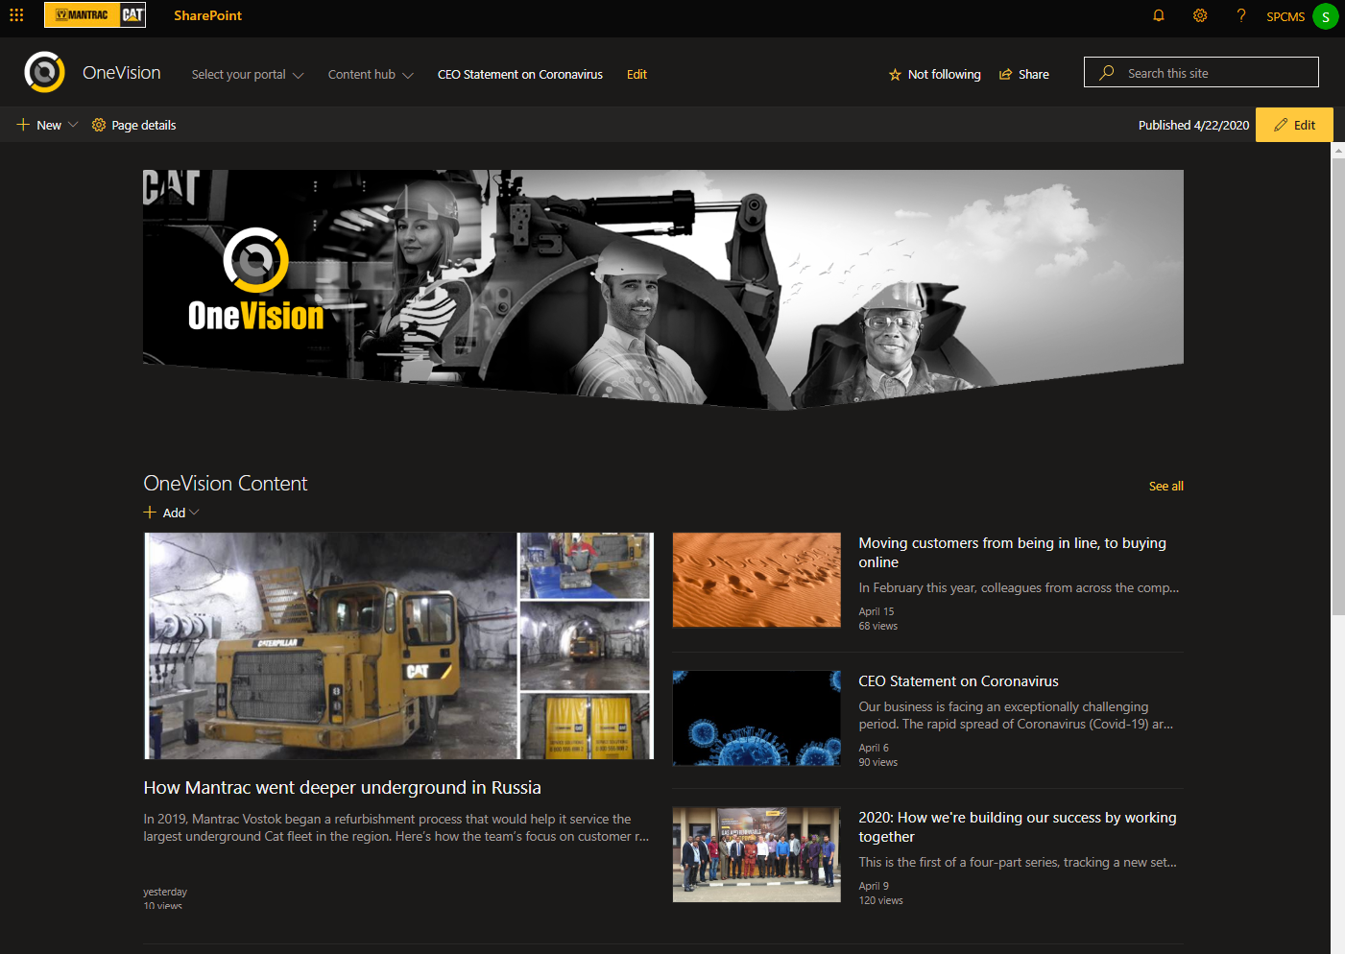

[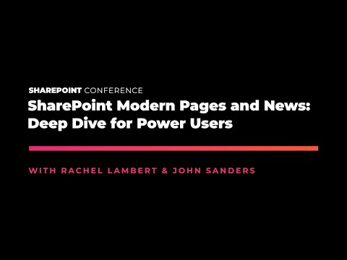](https://www.youtube.com/watch?v=JfXouxz7cGk) [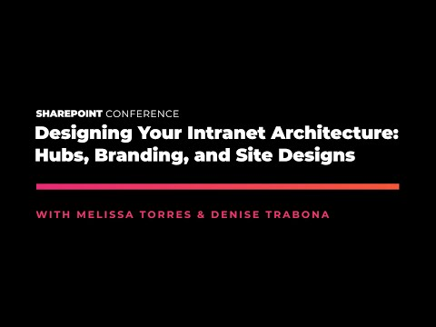](https://www.youtube.com/watch?v=7W2-ztwu6I8)

## Hub sites

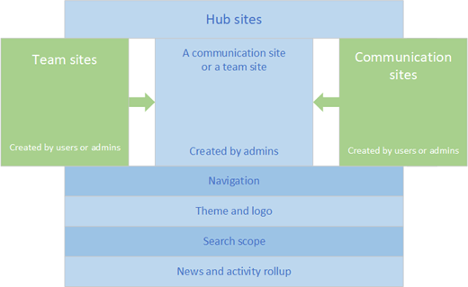To organize departments/teams/projects/events etc. admins need to explore [**Hub site**](https://support.office.com/en-gb/article/what-is-a-sharepoint-hub-site-fe26ae84-14b7-45b6-a6d1-948b3966427f?ui=en-US&rs=en-GB&ad=GB) **&** [**Plan Hub sites**](https://docs.microsoft.com/en-gb/sharepoint/planning-hub-sites).

**OneVision** portal could be a hub-site by design, and other independent and content generating/contributing departments such as HR, IT, Finance, Leadership, Frontline etc. could be created as separate Communication sites, possibly applying similar theme and site-designs and schema – then OneVision portal would only need to use cross site query or search – webparts to facilitate aggregation.

*But, OneVision at present is not setup as Hub site to keep things within scope and simplicity - <and there is scope for improvement in that regard>*

### Site template

Creating a communication site or a team site?

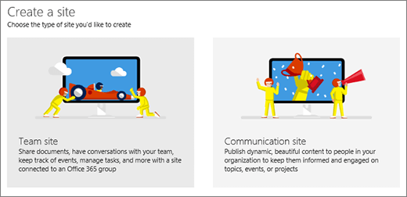Use a [**communication site**](https://support.microsoft.com/en-us/office/create-a-communication-site-in-sharepoint-online-7fb44b20-a72f-4d2c-9173-fc8f59ba50eb) to broadcast information out to a broad audience. With a communication site, typically only a small set of members contribute content that is consumed by a much larger audience. If you want to collaborate with other members of your team or with others on a specific project, a [team site](https://support.office.com/en-us/article/create-a-team-site-in-sharepoint-ef10c1e7-15f3-42a3-98aa-b5972711777d) is the better choice. With a [**team site**](https://support.office.com/en-us/article/create-a-team-site-in-sharepoint-ef10c1e7-15f3-42a3-98aa-b5972711777d), typically all or most members can contribute content to the site and the information is limited to only the members of the team or project and specific stakeholders.

**Note:** SharePoint Online top-level sites, such as Team or Communication site are not available as subsite templates, only as top-level sites. [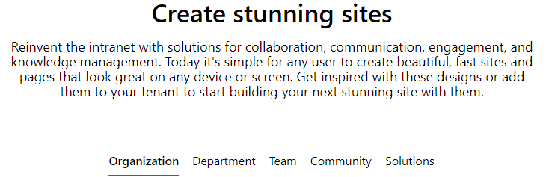](https://spdesign.azurewebsites.net/)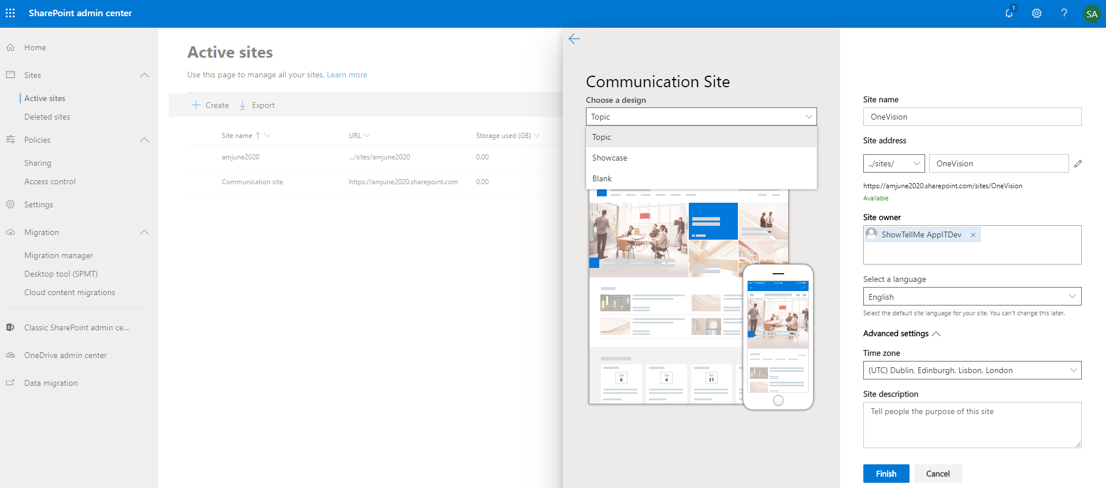 [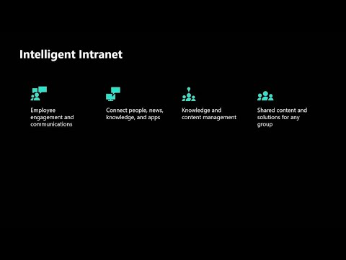](https://www.youtube.com/watch?v=XL7gyUunIac)

[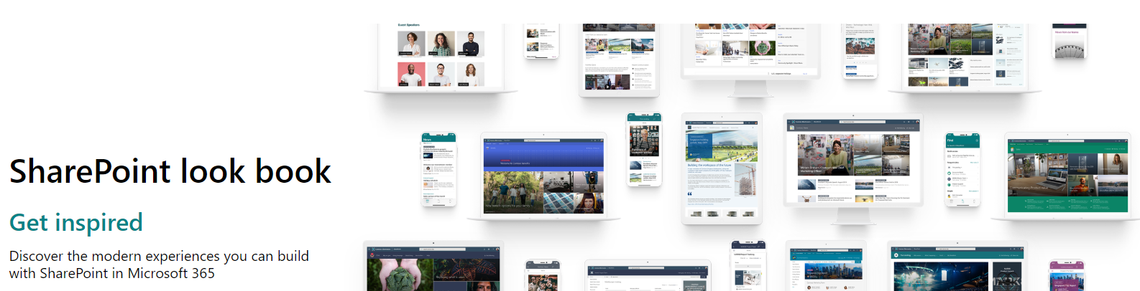](https://lookbook.microsoft.com/#templates)

[SharePoint Look book](https://lookbook.microsoft.com/#templates) - With this SharePoint community initiative - tenant administrators can create sites from pre-baked templates and sample layouts and content with applied site-designs etc.

### Site Deseign & Scripts

A SharePoint [site design](https://www.youtube.com/watch?v=ZjTnlbMJZfY) is a set of pre-defined actions that get executed to a site after the site has been created. With site designs, you can, for example, add lists with desired content types or columns, set the site logo, register an extension, or join the site to a hub site.

If you are familiar with PnP provisioning templates or SharePoint on-premises site definitions, SharePoint site designs are a similar thing.….

[**https://laurakokkarinen.com/the-ultimate-guide-to-sharepoint-site-designs-and-site-scripts/**](https://laurakokkarinen.com/the-ultimate-guide-to-sharepoint-site-designs-and-site-scripts/)

[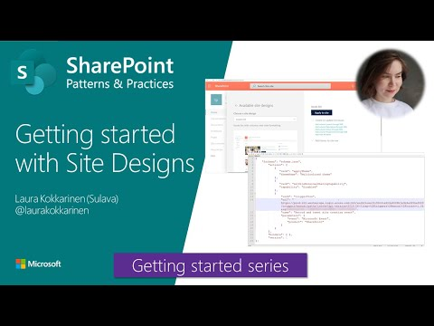](https://www.youtube.com/watch?v=ZjTnlbMJZfY) [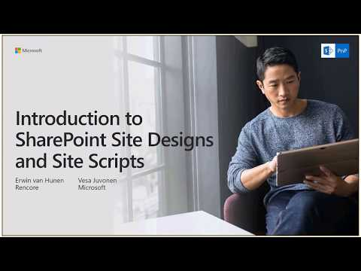](https://www.youtube.com/watch?v=oC2KwibfPrY)

## Branding

[Changing the Look](https://support.office.com/en-gb/article/change-the-look-of-your-sharepoint-site-06bbadc3-6b04-4a60-9d14-894f6a170818?ui=en-US&rs=en-GB&ad=GB)

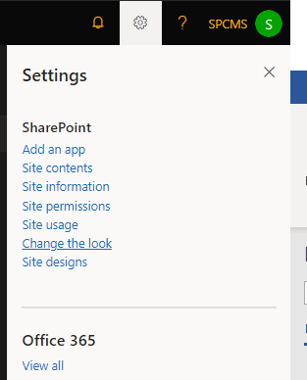 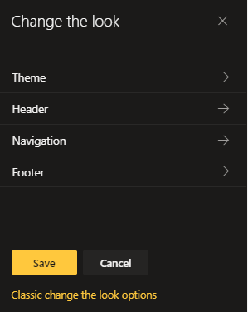

### Header & Footer

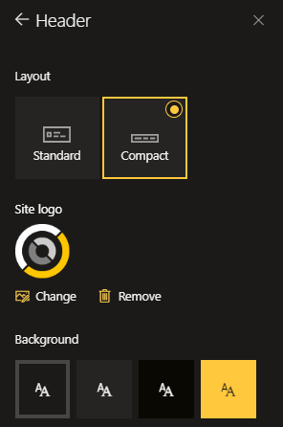 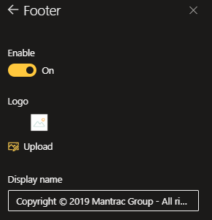 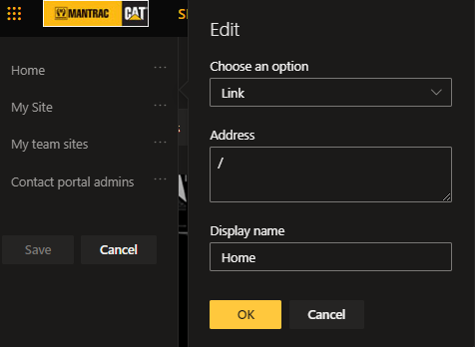



### Navigation

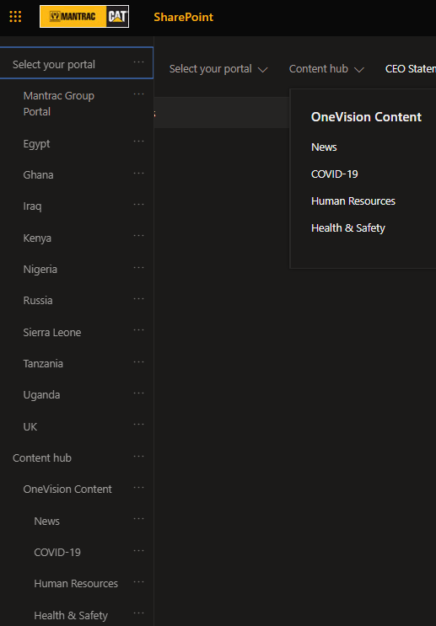 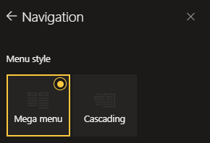 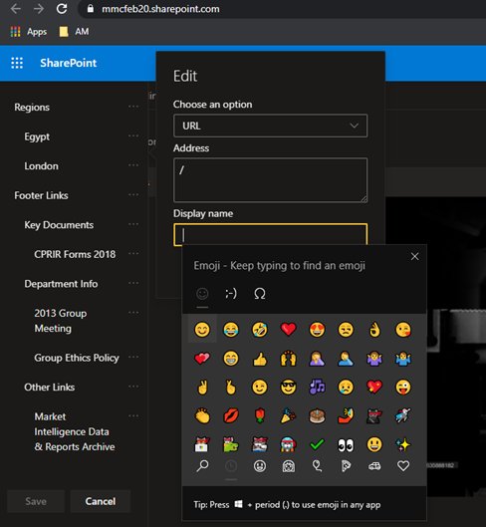

### Theme

[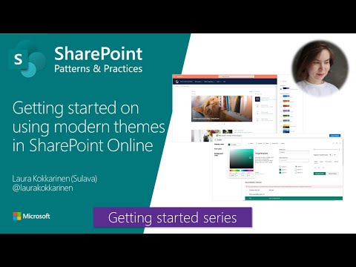](https://www.youtube.com/watch?v=hU7J09kdQ5c)Default themes are available from SharePoint.

[More customized themes](https://laurakokkarinen.com/how-to-create-a-multicolored-theme-for-a-modern-sharepoint-online-site/) can be created/deployed/applied with attached scripts below. These themes are deployed at tenant level and applied at site level.

   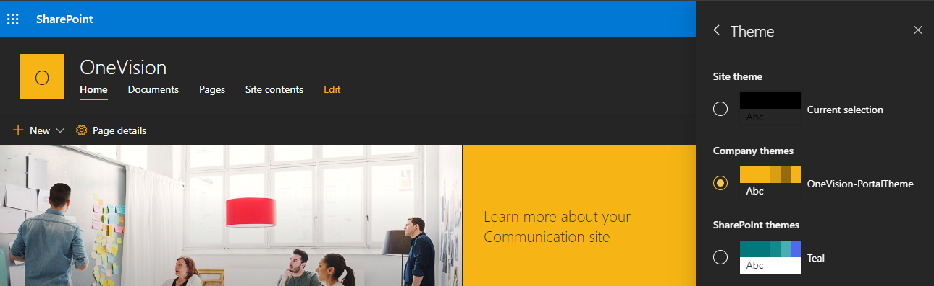

## Pages & Templates

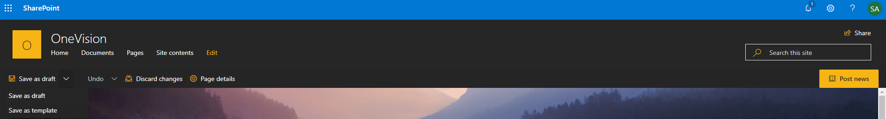

Create a page, choose a page template, add/edit layout with sections and header options and comments enable/disable on each page etc.…

[**Create & use modern pages**](Create%20&%20use%20modern%20pages)

<https://support.office.com/en-us/article/create-and-use-modern-pages-on-a-sharepoint-site-b3d46deb-27a6-4b1e-87b8-df851e503dec>

[**Image sizing and scaling in SharePoint modern pages**](Image%20sizing%20and%20scaling%20in%20SharePoint%20modern%20pages)

<https://support.microsoft.com/en-gb/office/image-sizing-and-scaling-in-sharepoint-modern-pages-dc510065-b5a5-4654-bc94-e3ecbbb57d8d>

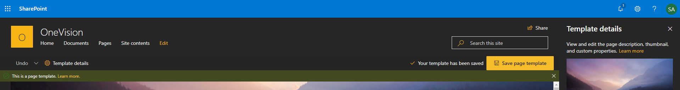

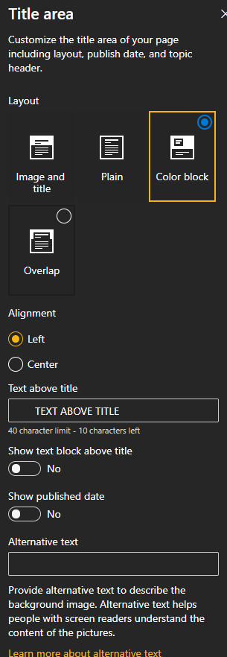 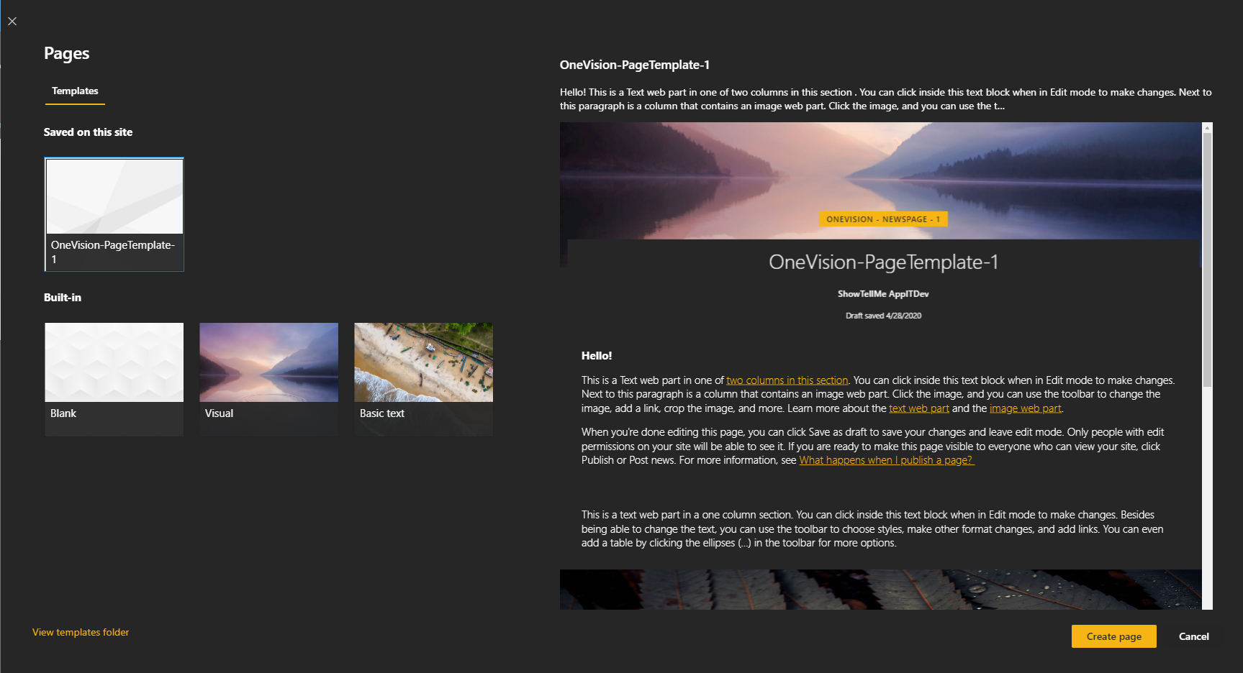

### Home page

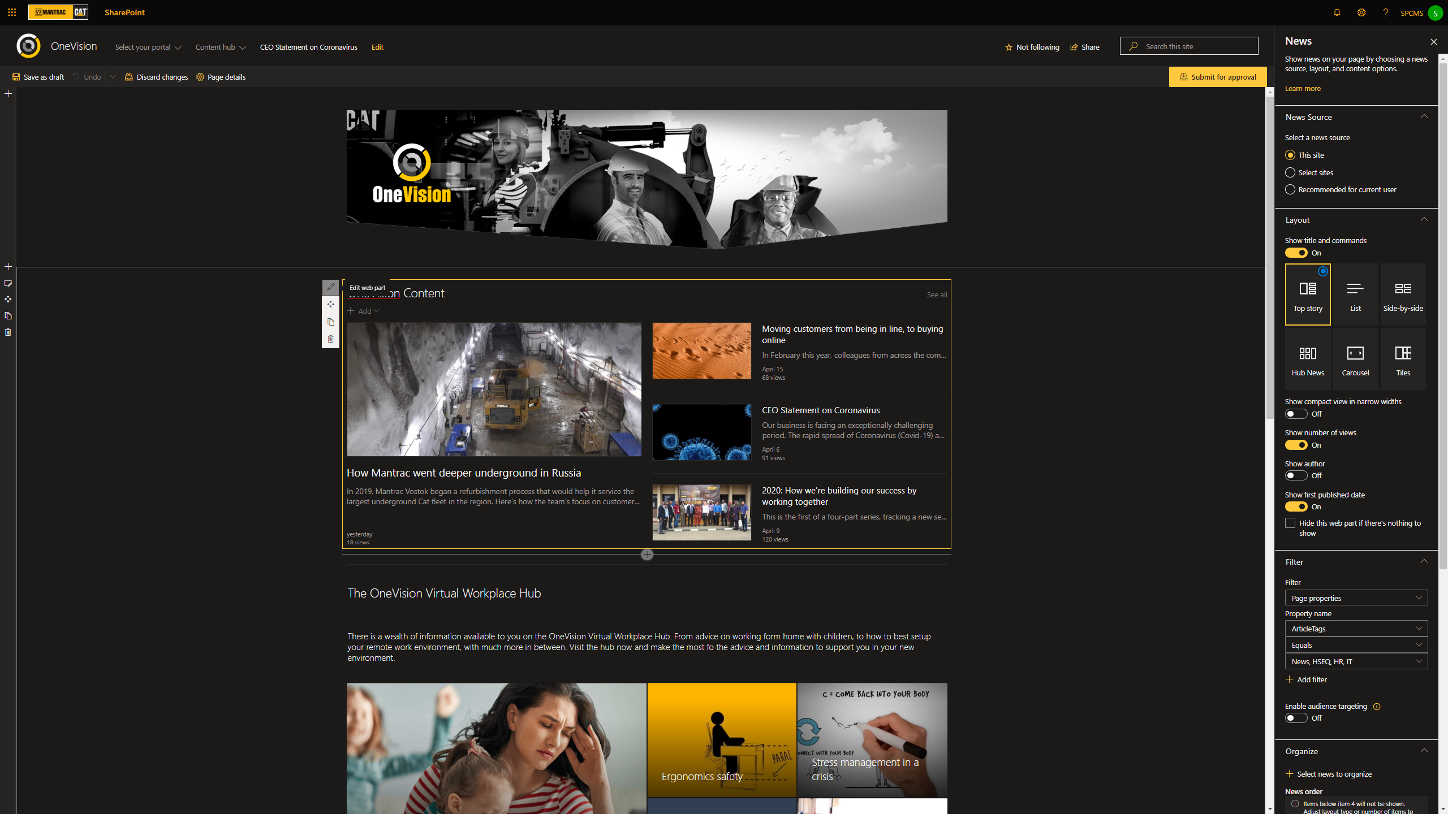

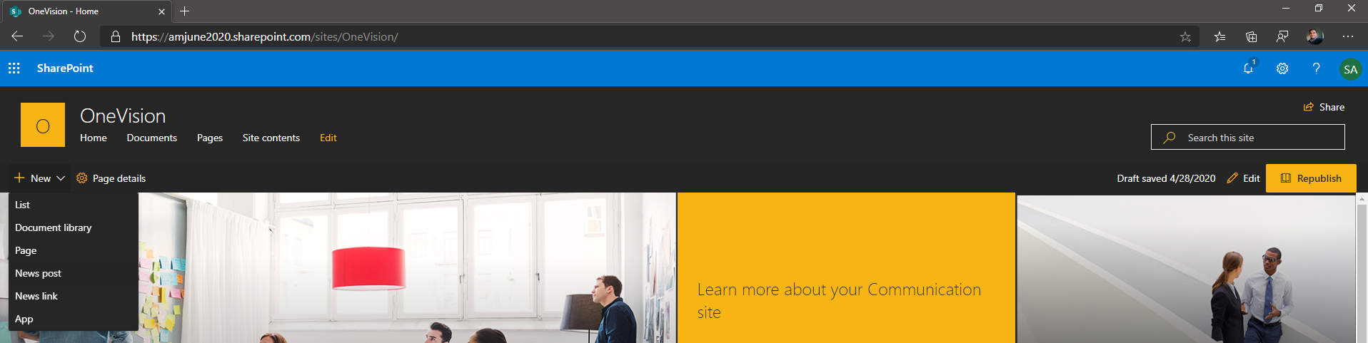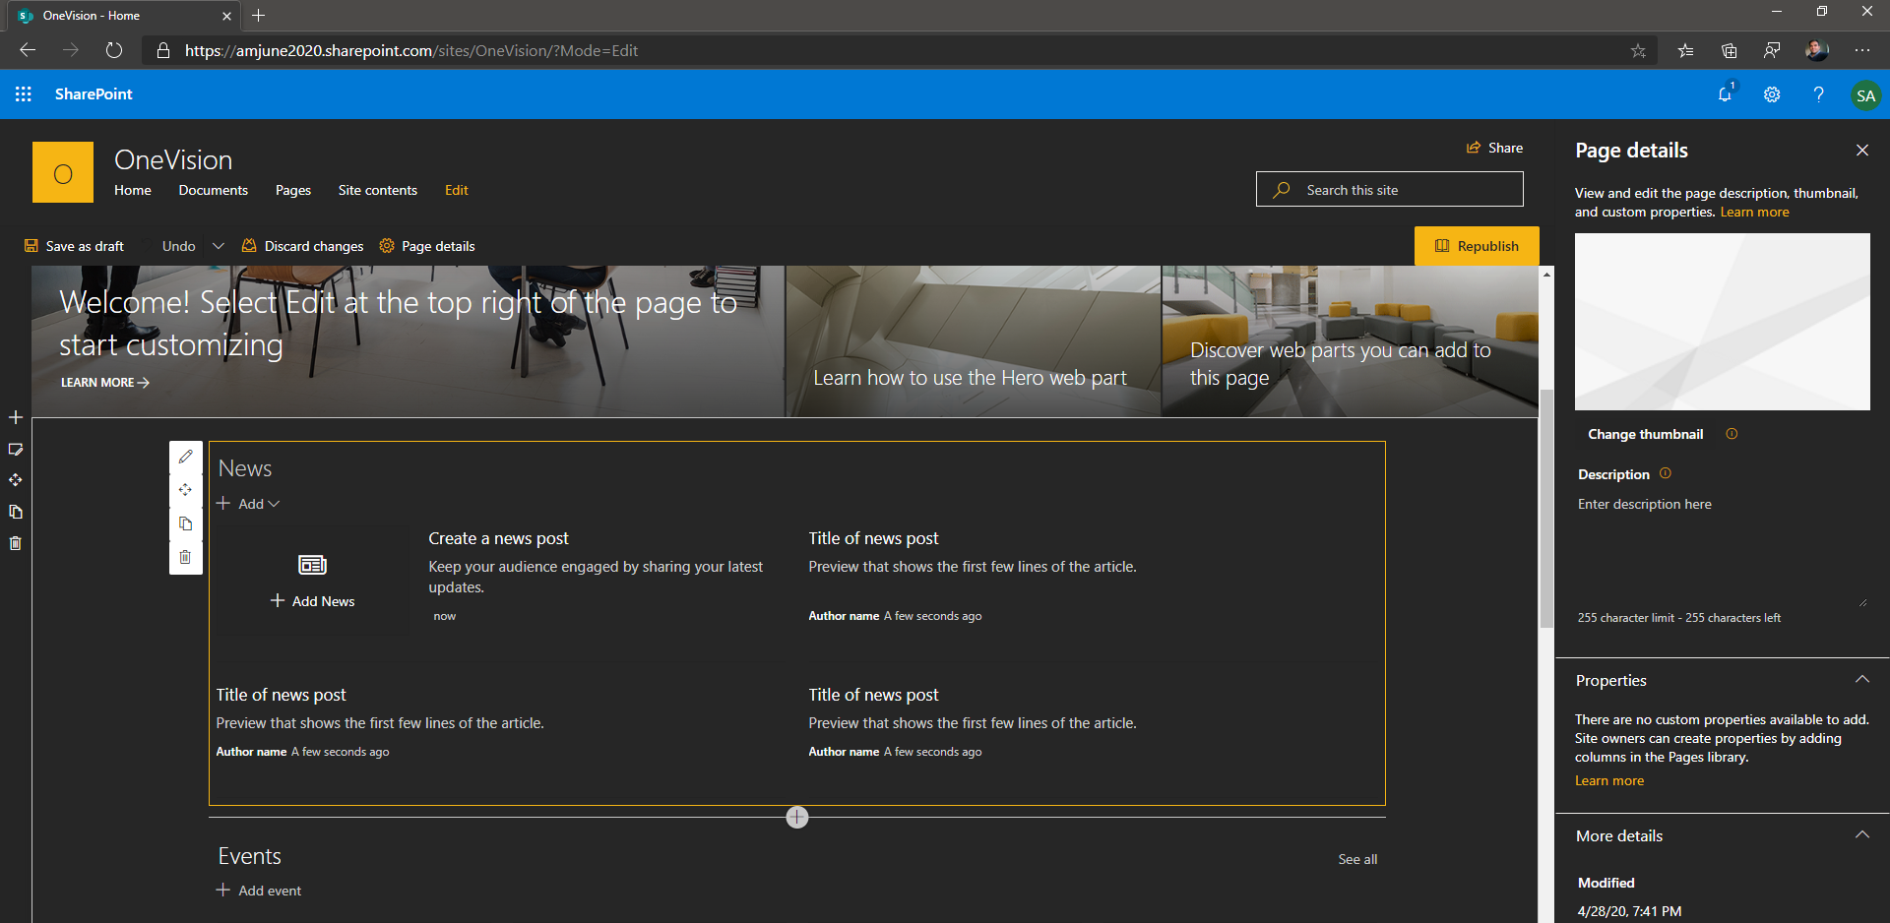

### OneVision Page

The OneVision Page contains News webparts for separate “ArticleTags” filter value and with the “Side-by-Side” layout and “12 posts” selection. This will enable the webpart to show at least 12 posts per article-category/tag and then the user can click “See all” top-right-hand link to navigate to another out-of-box page that will show all the articles (more than the max 12) for that webpart (and associated filter criteria etc). We also took the “See all” link-url and added it to top-navigation menu item and other quick-link navigation buttons – for better accessible/navigation to the articles.

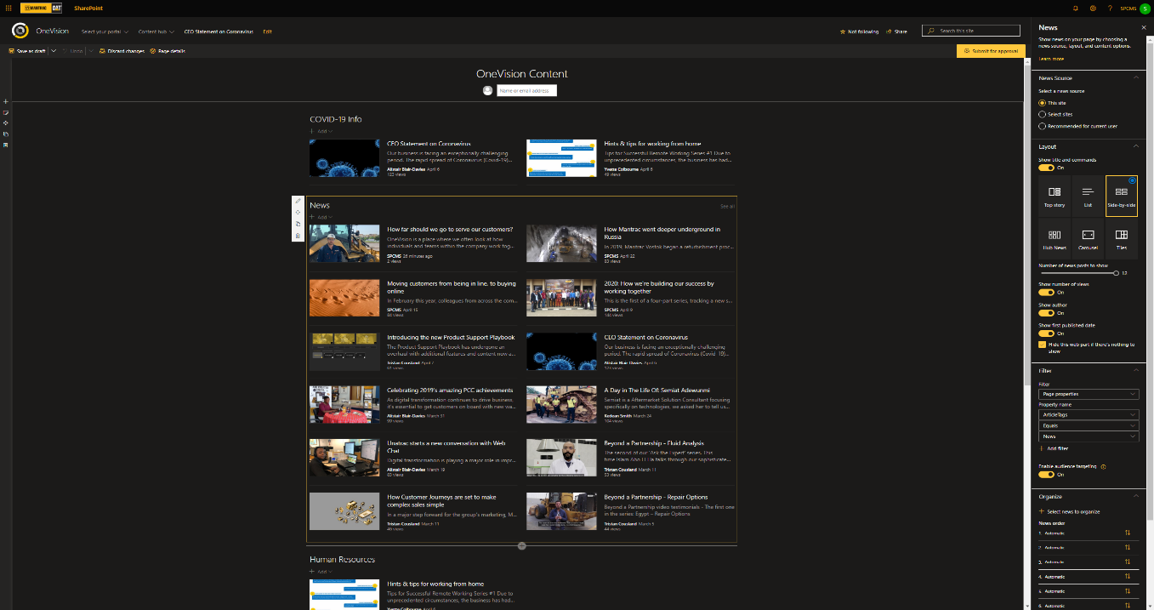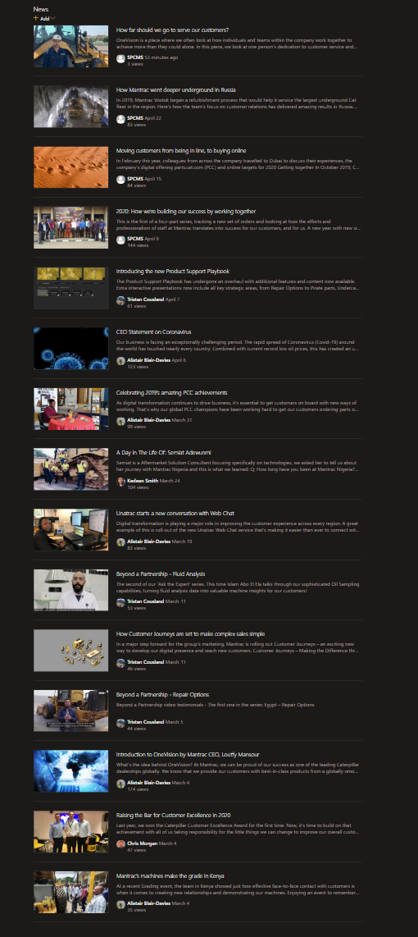

### Site pages Library & List View (Formatter View)

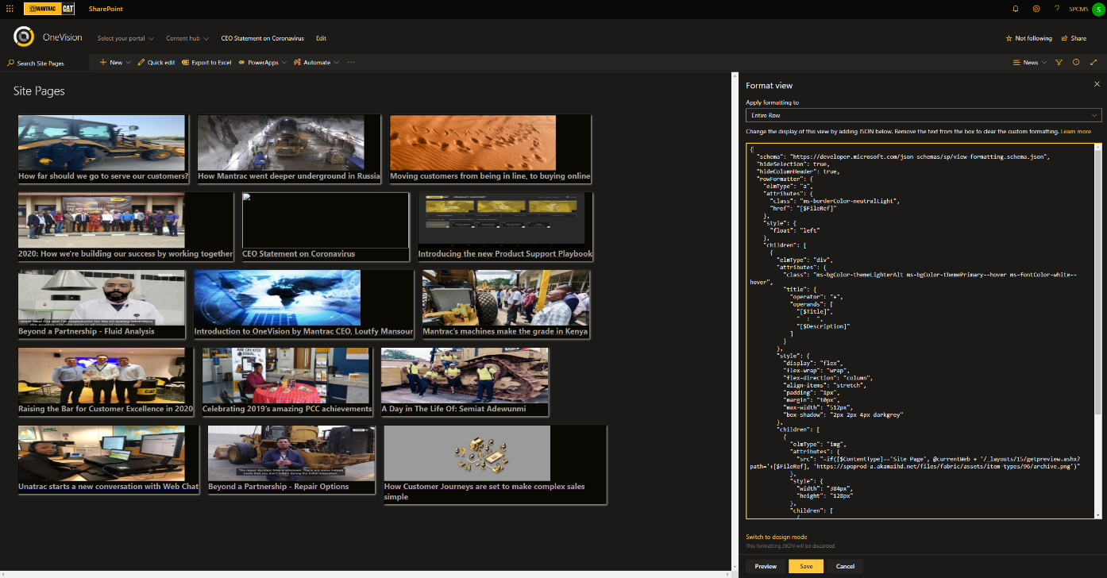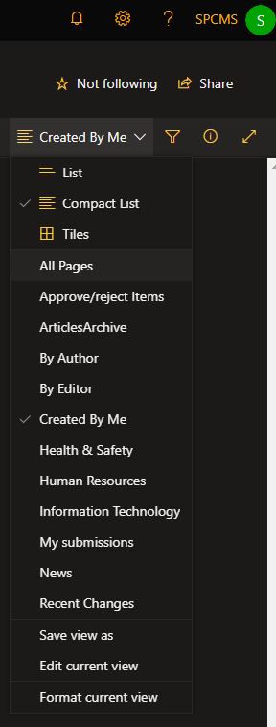

A View on a list/library is a presentation of rows/columns and applied filters and grouping etc.

The “Created By Me” view has been set as Default view and shows only [ME] filtered pages, that is those created by the current logged-in user only. To see others please select “All Pages” view from the left-hand menu on the Site Pages library.

** List view formatter as shown in above screen applied to News view is the ability to add specific JSON/Design styles to override the rendering of the entire view or just a column. This feature is not part of core solution – but has been left as reference.

[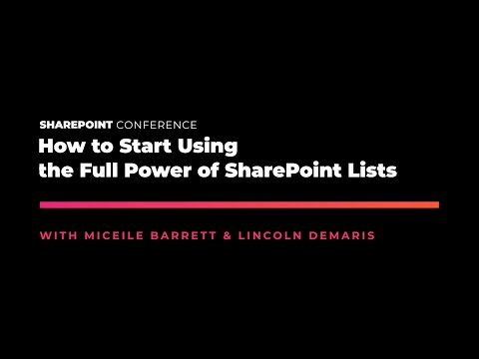](https://www.youtube.com/watch?v=3pTMXx_ZFgY) [](https://www.youtube.com/watch?v=5_eghVReCO0)

The settings page of the Site Pages library has few points to be noted, as follows:

1. **ArticleTag is a custom metadata-field or list-column** using “Create column” link below screenshot and choosing choice field type.
2. **Versioning Settings** have been set to “Create major and minor versions” and Draft item security as “Only users who can approve items and author of the item” And Check-out requirement to be set to Yes/Required before editing. Thus, exclusive check-out of page is required to make changes for all users (Site Owners/Admins) can override the checkout/discard-changes. Also, all users other than authors and approvers will only see published items and not able to see/update draft items. Hence, it is required to have edited pages to be Major-Checked-In/Published and Approved for changes/appear visible to all other audiences.
3. **Enterprise Metadata and Keywords** has been enabled, which added a tenant-wide field that looks-up any user-defined terms that have been previously updated/added via Items/Pages property.
4. **Audience targeting** has been enabled and this adds and Audience property to the list. SharePoint users/active-directory- groups-with-email can be added and webpart filters can be setup to target only specific users/groups.

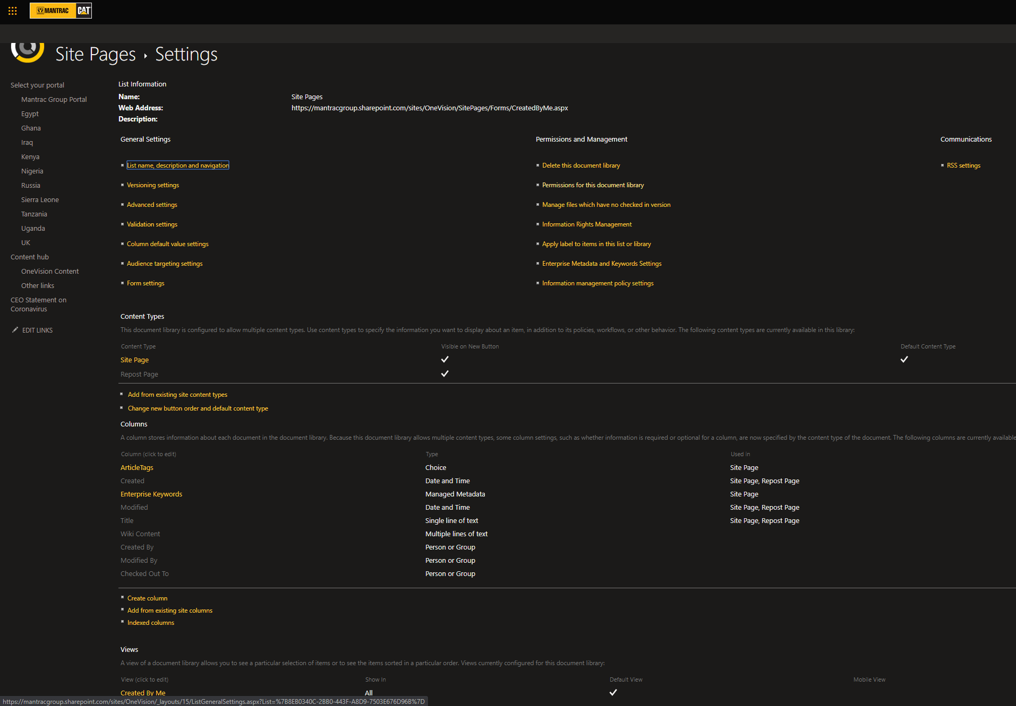

### Sections & Layouts

[](https://support.microsoft.com/en-gb/office/add-sections-and-columns-on-a-sharepoint-modern-page-fc491eb4-f733-4825-8fe2-e1ed80bd0899)

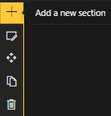 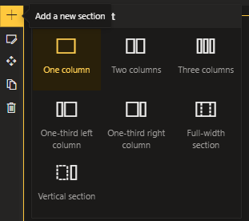 [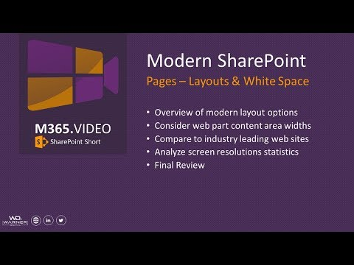](https://www.youtube.com/watch?v=YJ1w6N1jdPk)

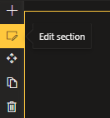 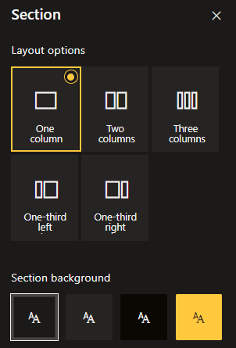 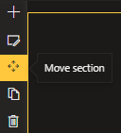 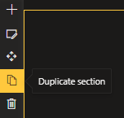 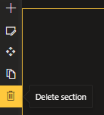

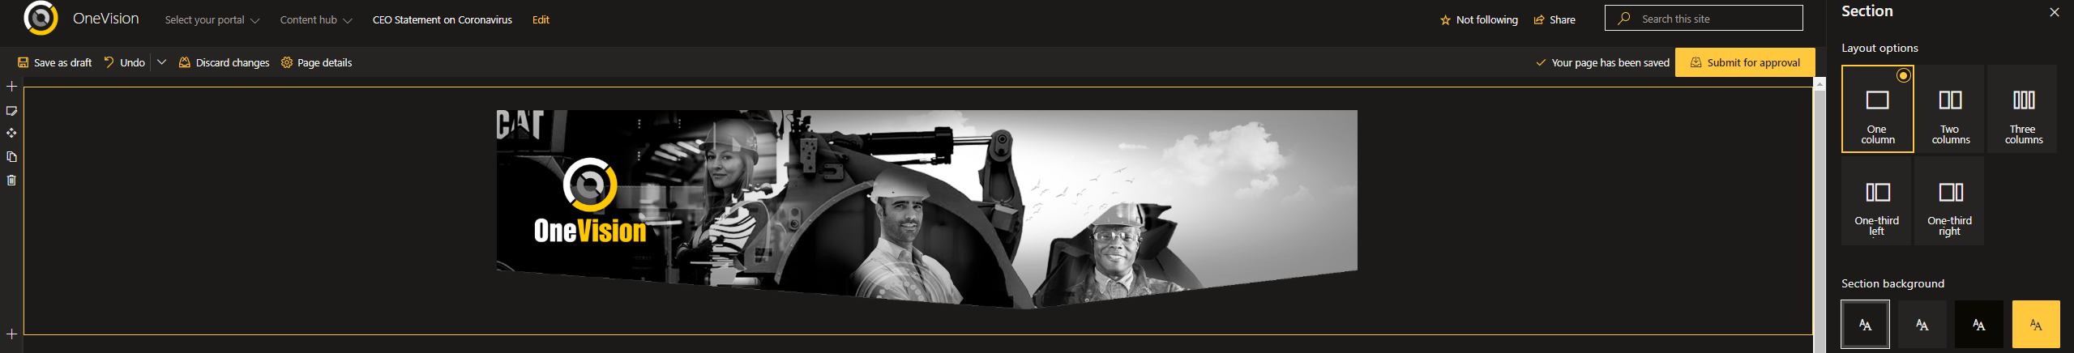

### Content Types & Metadata

[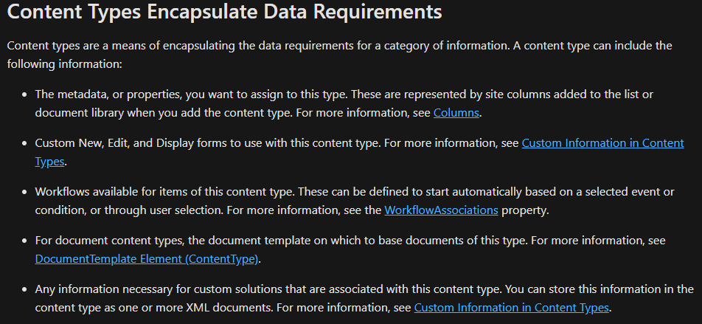](https://support.microsoft.com/en-us/office/introduction-to-content-types-and-content-type-publishing-e1277a2e-a1e8-4473-9126-91a0647766e5?ui=en-us&rs=en-us&ad=us)Within the context of OneVision intranet the primary document library is the “Site Pages” where new posts and links are created – These “Pages” can be typified/grouped by something called “[**content type**](https://support.microsoft.com/en-us/office/introduction-to-content-types-and-content-type-publishing-e1277a2e-a1e8-4473-9126-91a0647766e5?ui=en-us&rs=en-us&ad=us)” and this also contains a set of page-properties or metadata defined fields (which further have types, eg: ). As an example, in OneVision posts – we have added a Choice field to the “Site Pages” called “ArticleTags” and, an “Enterprise Tags” field that is a SharePoint feature to provide terms management at tenant and site levels.

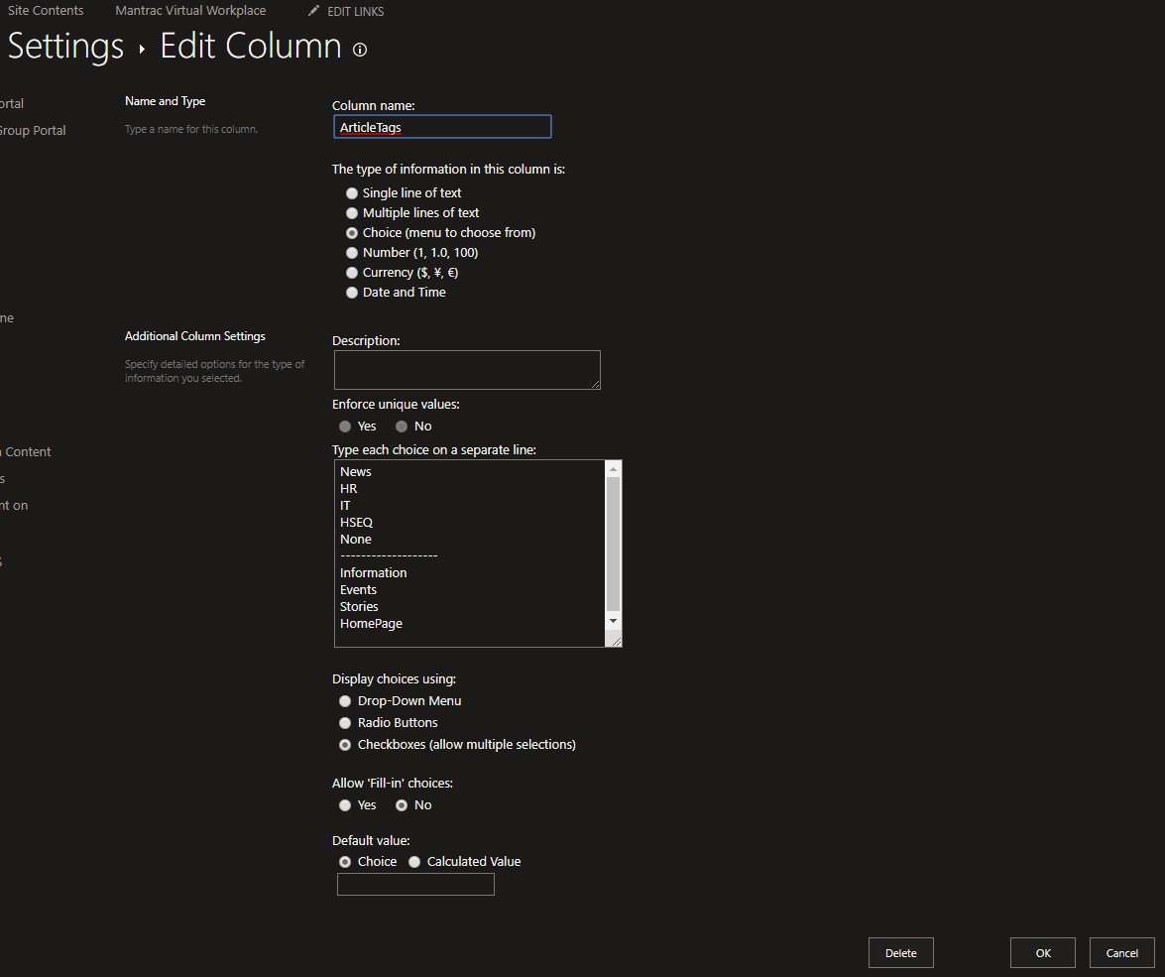

[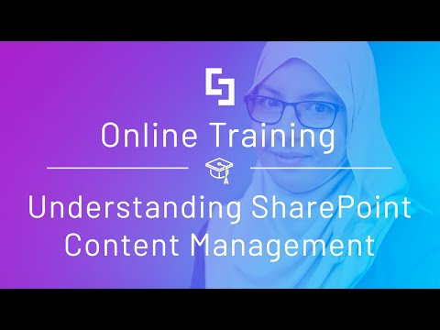](https://www.youtube.com/watch?v=Tt7wY-satmc) [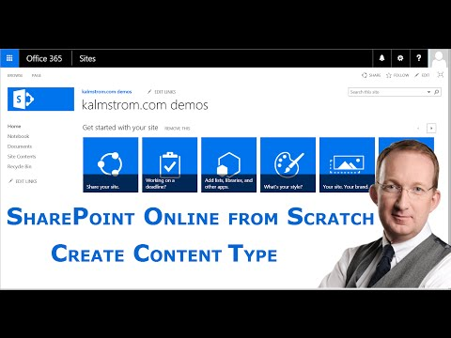](https://www.youtube.com/watch?v=Q7iKneIYimw) [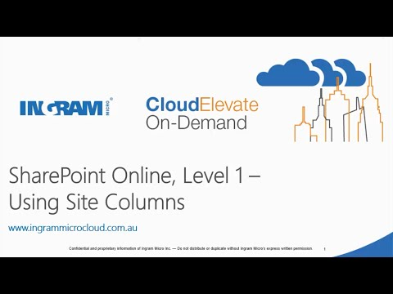](https://www.youtube.com/watch?v=LwFpjxsl47g)

## Webparts

[About Web Parts](https://docs.microsoft.com/en-us/sharepoint/dev/design/layout-patterns/) : <https://docs.microsoft.com/en-us/sharepoint/dev/design/layout-patterns>/

[**https://support.office.com/en-gb/article/using-web-parts-on-sharepoint-pages-336e8e92-3e2d-4298-ae01-d404bbe751e0**](https://support.office.com/en-gb/article/using-web-parts-on-sharepoint-pages-336e8e92-3e2d-4298-ae01-d404bbe751e0)

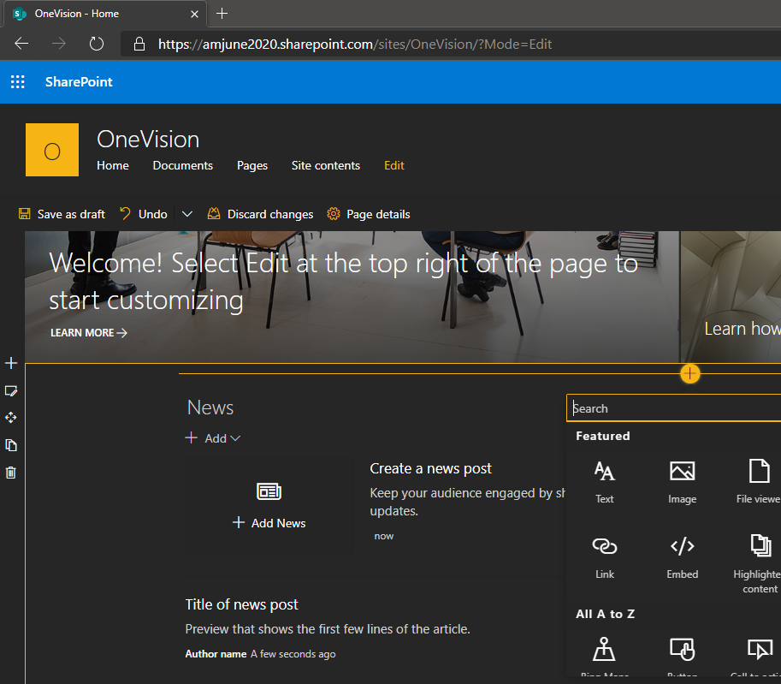 [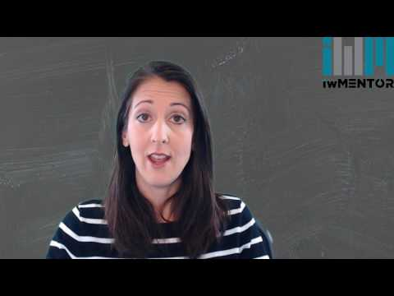](https://www.youtube.com/watch?v=T-PKNKlzh9c)

*\*\*OneVision has been presently setup as per scope and boundaries defined by client-requirements (options, constraints and context)*

### News & Quick-links Webpart

[**News Webparts**](https://support.office.com/en-gb/article/Use-the-News-web-part-on-a-SharePoint-page-C2DCEE50-F5D7-434B-8CB9-A7FEEFD9F165)

[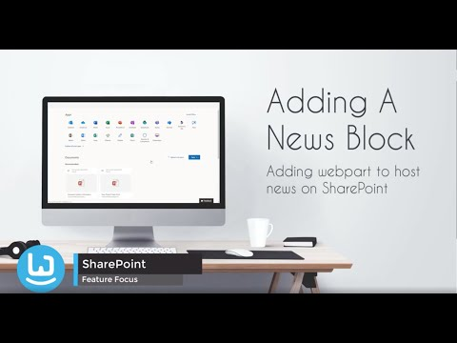](https://www.youtube.com/watch?v=TeJ-kQ9OXbE) [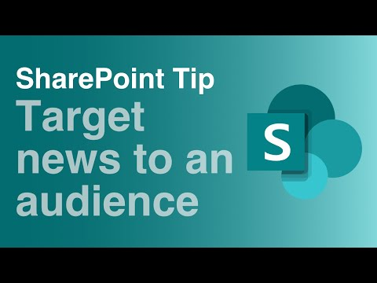](https://www.youtube.com/watch?v=fs6O3Cry02w) [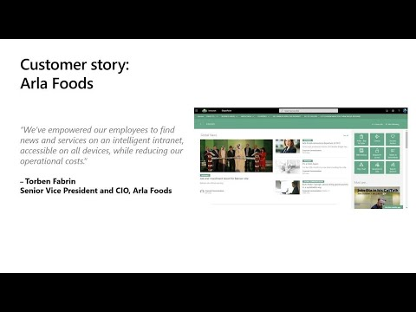](https://www.youtube.com/watch?v=j7Ni_erBMeE)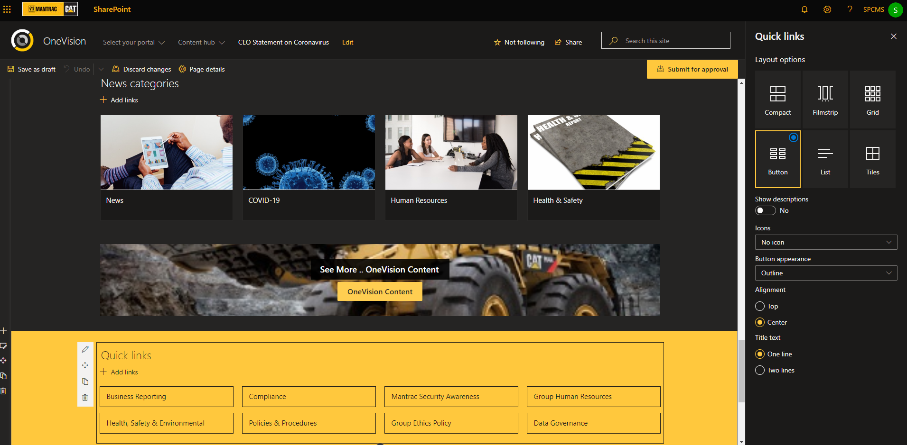

### What’s next & Here!

Multilingual Publishing & Variations

[Create multilingual communication sites, pages, and news](https://support.office.com/en-us/article/create-multilingual-communication-sites-pages-and-news-2bb7d610-5453-41c6-a0e8-6f40b3ed750c?ui=en-US&rs=en-US&ad=US)

[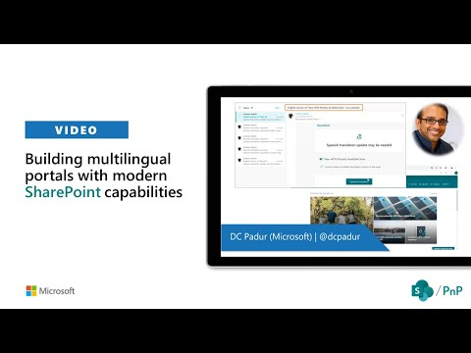](https://www.youtube.com/watch?v=V3mtnoIlFEY)

[Mixed/Augmented Reality with SharePoint](https://support.office.com/en-gb/article/sharepoint-spaces-7b65edfb-7cc9-42e3-af37-178d79364a5e)

[**https://www.exploresharepointspaces.com/**](https://www.exploresharepointspaces.com/)

[](https://www.youtube.com/watch?v=KD5ZgYdA8f4) [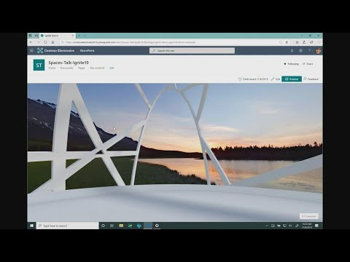](https://www.youtube.com/watch?v=pg_6vFAh-VM)

[**Power Virtual Agents**](https://docs.microsoft.com/en-us/power-virtual-agents/fundamentals-what-is-power-virtual-agents) & [AI **Builder**](https://docs.microsoft.com/en-us/ai-builder/overview)

 [](https://www.youtube.com/watch?v=VfDItvantTs) [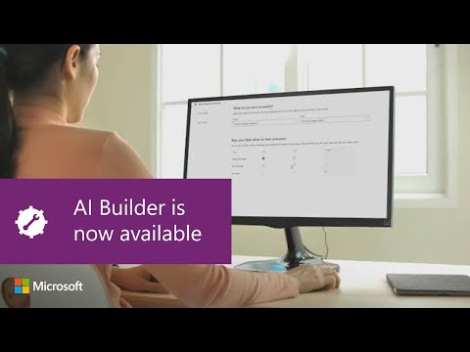](https://www.youtube.com/watch?v=86IXxN6d_kA)

## Governance + Security + Administration

### Permissions & Sharing

** This what the site administrators will see .. Site owners will not see the “Site Collection Administration” section below.

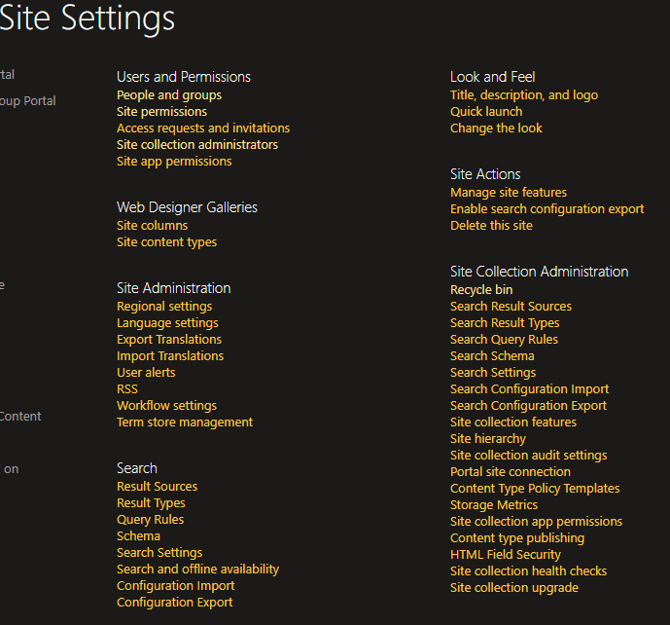

Site Permissions for users and groups can be managed from this screen “/_layouts/15/users.aspx” – “Site permissions” menu.

* As can be seen from screen below, there are Groups for OneVision [Approvers, Members, Owners and Visitors] and their corresponding permission-levels which determine the scope of their interaction/actions. OneVision has basic security setup and generally, Site Page authors should be added to “Members” and Owners would have all permissions like deleting lists/libraries and overriding check-outs. Visitors includes the system user “everyone” and hence, all logged-in users can access/view published pages/articles. Also using “Check Permissions” specific user/groups access can be verified.

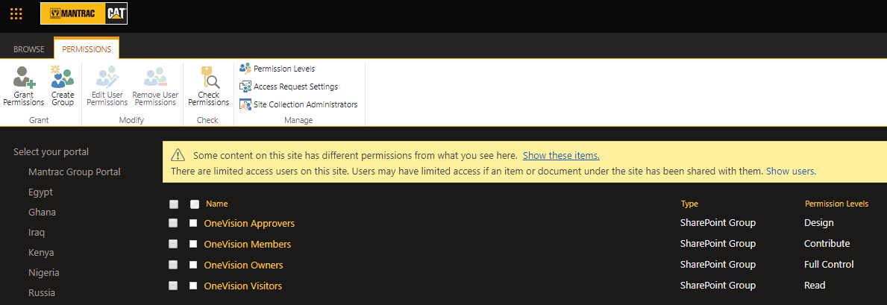 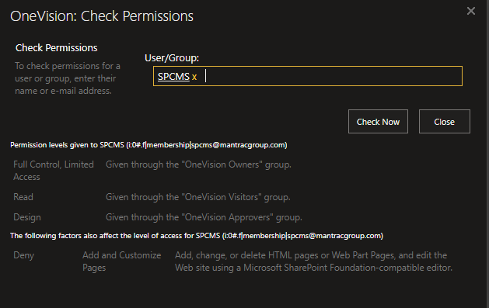

More reference videos can be found below for additional know how on security and permissions.

[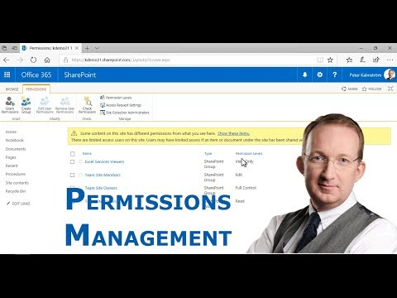](https://www.youtube.com/watch?v=A48pm46zyTw) [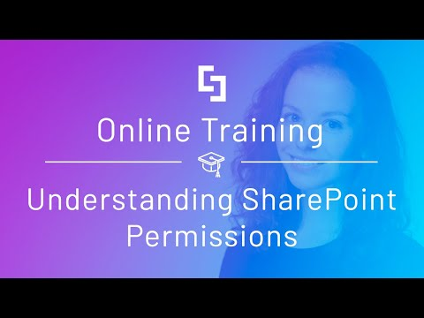](https://www.youtube.com/watch?v=ZEWhSV5qcUg) [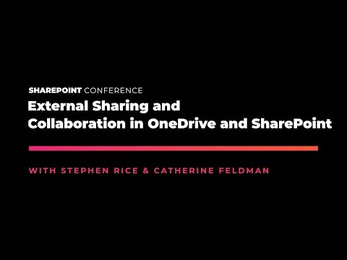](https://www.youtube.com/watch?v=b8r_NUyImuk) [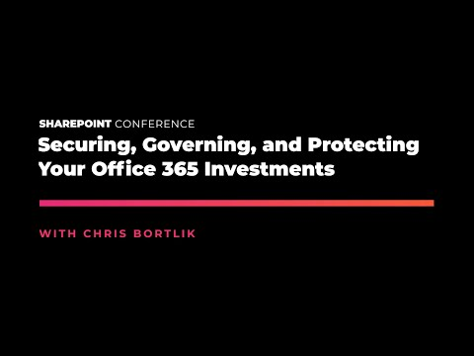](https://www.youtube.com/watch?v=ici-N7ST_BM)

[**Sensitivity Labels**](https://docs.microsoft.com/en-us/microsoft-365/compliance/sensitivity-labels?view=o365-worldwide#what-a-sensitivity-label-is)

[**https://docs.microsoft.com/en-us/microsoft-365/compliance/sensitivity-labels-sharepoint-onedrive-files?view=o365-worldwide**](https://docs.microsoft.com/en-us/microsoft-365/compliance/sensitivity-labels-sharepoint-onedrive-files?view=o365-worldwide)

**Information Protection**

[**https://docs.microsoft.com/en-us/office365/servicedescriptions/microsoft-365-service-descriptions/microsoft-365-tenantlevel-services-licensing-guidance/microsoft-365-security-compliance-licensing-guidance#information-protection**](https://docs.microsoft.com/en-us/office365/servicedescriptions/microsoft-365-service-descriptions/microsoft-365-tenantlevel-services-licensing-guidance/microsoft-365-security-compliance-licensing-guidance#information-protection)

**M365 Compliance documentation**

[**https://docs.microsoft.com/en-us/microsoft-365/compliance/?view=o365-worldwide**](https://docs.microsoft.com/en-us/microsoft-365/compliance/?view=o365-worldwide)

**Enterprise Security documentation**

[**https://docs.microsoft.com/en-us/enterprise-mobility-security/**](https://docs.microsoft.com/en-us/enterprise-mobility-security/)

[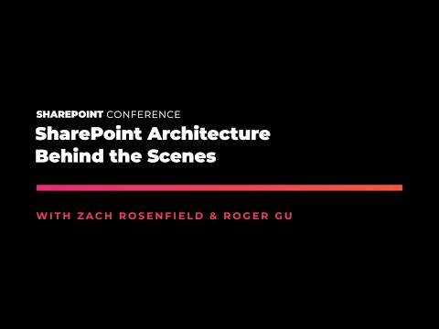](https://www.youtube.com/watch?v=S53bhAODRoA) [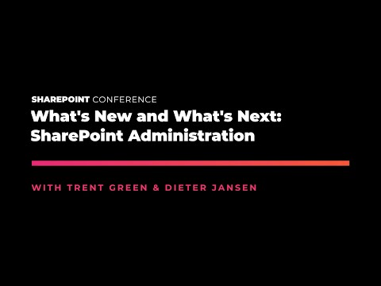](https://www.youtube.com/watch?v=mnh5QxyZ6Z0)

# More References

|  |  |
| --- | --- |
| **Topic** | **URI** |
|  |  |
| **Appflow IT Solutions Ltd – Services**  [**sharepointjob@outlook.com**](mailto:sharepointjob@outlook.com)  [**appflowit@appflowit.uk**](mailto:appflowit@appflowit.uk)  -> Full-lifecycle Last Mile Productivity apps dev  -> Full-lifecycle Legacy apps analysis/rewrite/migration  -> O365 Full stack intranet/extranet build and more  -> Business Case evaluations/consulting and more  -> Project insurance and recovery | [**https://www.linkedin.com/in/aaseafm-appflowit/detail/recent-activity/posts/**](https://www.linkedin.com/in/aaseafm-appflowit/detail/recent-activity/posts/)  [**https://github.com/appflowitdeveloper/O365Azure**](https://github.com/appflowitdeveloper/O365Azure) |
| **End user SharePoint help** | [**HTTPS://SUPPORT.OFFICE.COM/EN-GB/SHAREPOINT/**](HTTPS://SUPPORT.OFFICE.COM/EN-GB/SHAREPOINT/) |
| **SharePoint online video trainings** | (M365) <https://support.office.com/en-us/article/microsoft-365-basics-video-training-396b8d9e-e118-42d0-8a0d-87d1f2f055fb?wt.mc_id=otc_home>  **(SharePoint)** [**https://support.office.com/en-us/article/sharepoint-online-video-training-cb8ef501-84db-4427-ac77-ec2009fb8e23**](https://support.office.com/en-us/article/sharepoint-online-video-training-cb8ef501-84db-4427-ac77-ec2009fb8e23) |
| **SharePoint documentation** | [**https://docs.microsoft.com/en-us/sharepoint/**](https://docs.microsoft.com/en-us/sharepoint/) |
| **SharePoint Modern experience guidance** | [**https://docs.microsoft.com/en-us/sharepoint/guide-to-sharepoint-modern-experience**](https://docs.microsoft.com/en-us/sharepoint/guide-to-sharepoint-modern-experience) |
| **Office-M365 – Your plan/license features** | [**https://www.microsoft.com/en-gb/microsoft-365/compare-microsoft-365-enterprise-plans**](https://www.microsoft.com/en-gb/microsoft-365/compare-microsoft-365-enterprise-plans) |
| **Office/M365 – Roadmap** | [**https://www.microsoft.com/en-us/microsoft-365/roadmap?filters=O365**](https://www.microsoft.com/en-us/microsoft-365/roadmap?filters=O365) |
| **Blog: Modern OOB Webparts elaborated** | [**https://wonderlaura.com/2016/10/17/new-modern-web-parts-full-list/**](https://wonderlaura.com/2016/10/17/new-modern-web-parts-full-list/)  [**https://support.office.com/en-gb/article/using-web-parts-on-sharepoint-pages-336e8e92-3e2d-4298-ae01-d404bbe751e0**](https://support.office.com/en-gb/article/using-web-parts-on-sharepoint-pages-336e8e92-3e2d-4298-ae01-d404bbe751e0) |
| **Blog: Images, pixels & sizing** | [**https://tracyvanderschyff.com/2018/05/03/creating-banners-for-your-sharepoint-online-pages/**](https://tracyvanderschyff.com/2018/05/03/creating-banners-for-your-sharepoint-online-pages/)  [**https://medium.com/@smcollier/hero-webpart-jigsaws-ad59f52deb91**](https://medium.com/@smcollier/hero-webpart-jigsaws-ad59f52deb91)  [**https://support.microsoft.com/en-gb/office/image-sizing-and-scaling-in-sharepoint-modern-pages-dc510065-b5a5-4654-bc94-e3ecbbb57d8d**](https://support.microsoft.com/en-gb/office/image-sizing-and-scaling-in-sharepoint-modern-pages-dc510065-b5a5-4654-bc94-e3ecbbb57d8d) |
| **Blog: SharePoint Permissions** | [**https://sharepointmaven.com/sharepoint-permissions-simplified/**](https://sharepointmaven.com/sharepoint-permissions-simplified/) |
| **Power Platform (Ignite 2020)** | [**Power Automate**](https://www.youtube.com/watch?v=0P7wlxpDFII&list=PLQXpv_NQsPIAtZExrjxVzX-PoRfYYOV73)  **|** [**Power Apps**](https://www.youtube.com/watch?v=lMuOtZ__9dA&list=PLQXpv_NQsPIB1FZ_DbBxfxcuqz0bYBsj_) **|** [**Power-BI**](https://www.youtube.com/watch?v=8RKOPSRHV00&list=PLQXpv_NQsPICb0weCeLQw_MQQIP2PYc1C) |

# Hope this helped!

The purpose of this document:

1. The big picture of the “OneVision” intranet portal - created for [**MulberryMC.com**](https://www.mulberrymc.com/us/team-london/) and their client [MantracGroup.com](https://www.mantracgroup.com/)
2. Describe the components used. (generic terminology and specific pages explained and webparts detailed, and external-references-for-how-to)
3. Enumerating various scenarios where things can/could be changed and the how-to; and if-any such scenario where “Exception/Avoiding/Not-Implemented” is involved and how-to overcome them through self-service or through getting technical-support.
4. Security & Permissions in details and stock-how-to as reference.

Kindly feedback your thoughts and suggestions and ideas, that would be magical to get them😊

Kind Regards, **Aaseaf Mahkahti |** [**sharepointjob@outlook.com**](mailto:sharepointjob@outlook.com)

**https://www.linkedin.com/in/aaseafm-appflowit**

# DISCLAIMER

This document is provided “as-is”. Information and views expressed in this document, including URL and other Internet Web site references, may change without notice. You bear the risk of using it.

Some examples depicted herein are provided for illustration only and are fictitious.  No real association or connection is intended or should be inferred.

This document does not provide you with any legal rights to any intellectual property in any Appflow IT Solutions Ltd. products. You may copy and use this document for your internal, reference purposes.

© 2020 Appflow IT Solutions Ltd. All rights reserved.